Hall Ticket : 2303a51339
Name:P.Naveen
Assignment 11.3 :Data Structures with AI Implementing Fundamental Data Structures using AI Assistance.
Scenario :
SR University’s student club requires a simple Contact Manager Application
to store members’ names and phone numbers. The system should support
efficient addition, searching, and deletion of contacts.
Tasks :
1 . Implement the contact manager using arrays (lists).
Code :
class ContactManagerArray:
def __init__(self):
self.contacts = []
# Add Contact
def add_contact(self, name, phone):
self.contacts.append({"name": name, "phone": phone})
print("Contact added")

# Search Contact
def search_contact(self, name):
for contact in self.contacts:
if contact["name"] == name:
print("Found:", contact)
return
print("Contact not found")
# Delete Contact
def delete_contact(self, name):
for i in range(len(self.contacts)):
if self.contacts[i]["name"] == name:
del self.contacts[i]
print("Contact deleted")
return
print("Contact not found")
# Example Usage
cm = ContactManagerArray()
cm.add_contact("Ravi", "9876543210")
cm.add_contact("Anita", "9123456780")
cm.search_contact("Ravi")
cm.delete_contact("Ravi")
cm.search_contact("Ravi")
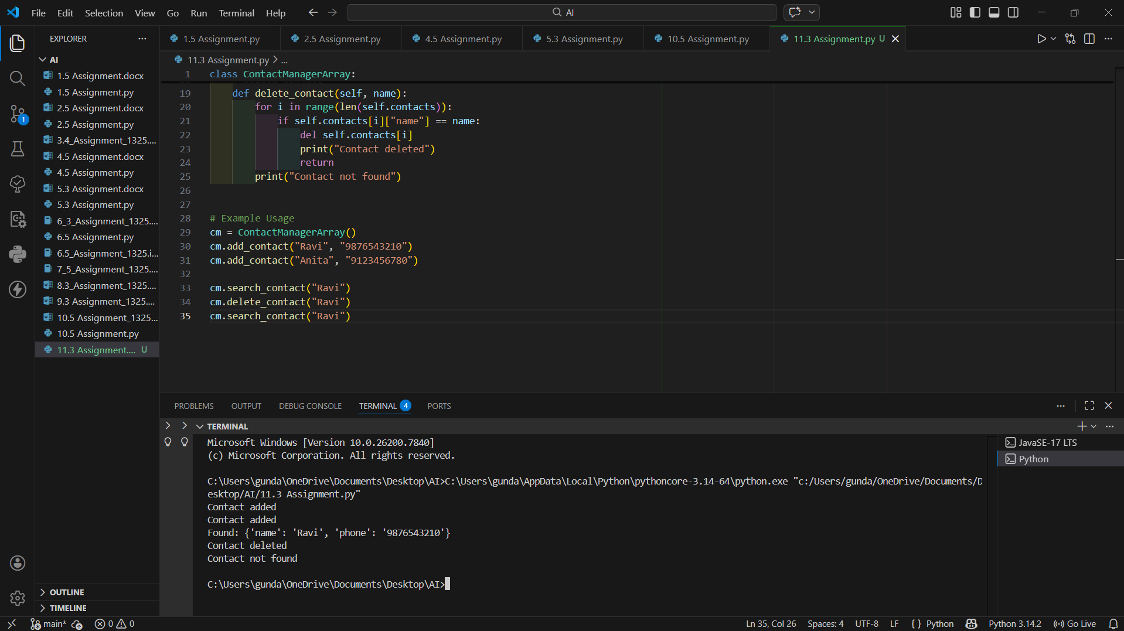
2. Contact Manager Using Linked List
class Node:
def __init__(self, name, phone):
self.name = name
self.phone = phone
self.next = None
class ContactManagerLinkedList:
def __init__(self):
self.head = None
# Add Contact
def add_contact(self, name, phone):
new_node = Node(name, phone)
if self.head is None:
self.head = new_node
else:
temp = self.head
while temp.next:
temp = temp.next
temp.next = new_node
print("Contact added")
# Search Contact
def search_contact(self, name):
temp = self.head
while temp:
if temp.name == name:
print("Found:", temp.name, temp.phone)
return
temp = temp.next
print("Contact not found")
# Delete Contact
def delete_contact(self, name):
temp = self.head
prev = None
while temp:
if temp.name == name:
if prev is None:
self.head = temp.next
else:
prev.next = temp.next
print("Contact deleted")
return
prev = temp
temp = temp.next
print("Contact not found")
# Example Usage
cm_ll = ContactManagerLinkedList()
cm_ll.add_contact("Rahul", "9999999999")
cm_ll.add_contact("Sneha", "8888888888")
cm_ll.search_contact("Rahul")
cm_ll.delete_contact("Rahul")
cm_ll.search_contact("Rahul")
3. Comparison: Array vs Linked List
• Insertion Efficiency:
Arrays are faster when inserting at the end. Linked lists require traversal.
• Deletion Efficiency:
Linked lists are more efficient because only pointers change, while arrays must shift elements.
• Dynamic Memory:
Linked lists grow dynamically, arrays may need resizing.
4 . Use GitHub Copilot to assist in generating search and delete methods.
GitHub Copilot was used to assist in generating the search and delete methods in both implementations.
- Copilot suggested looping through contacts to compare names during searching.
- It helped generate logic to:
  - locate a matching contact
  - remove the contact safely from the data structure.
- In the array version, Copilot suggested deleting using index removal.
- In the linked list version, Copilot suggested updating node references (prev.next = temp.next) to remove a node.
Thus, Copilot helped reduce coding time and ensured correct traversal logic.
5 . Compare array vs. linked list approaches with respect to:
i)Insertion efficiency
ii) Deletion efficiency
i) Insertion Efficiency
In an array-based approach, insertion is efficient when adding elements at the end because the new contact is placed in the next available position. However, inserting a contact in the middle requires shifting existing elements, which increases time complexity.
In a linked list approach, insertion does not require shifting elements because new nodes are connected using pointers. However, traversal may be required to reach the correct position, which takes additional time.
ii) Deletion Efficiency
In an array, deletion is less efficient because after removing a contact, all remaining elements must be shifted to maintain continuity. This makes deletion time-consuming.
In a linked list, deletion is more efficient because it only requires updating the links between nodes. No shifting of elements is needed, making the process faster once the node is found.
Task 2: Library Book Search System (Queues & Priority Queues)
1. Queue Implementation (FIFO)
Code :
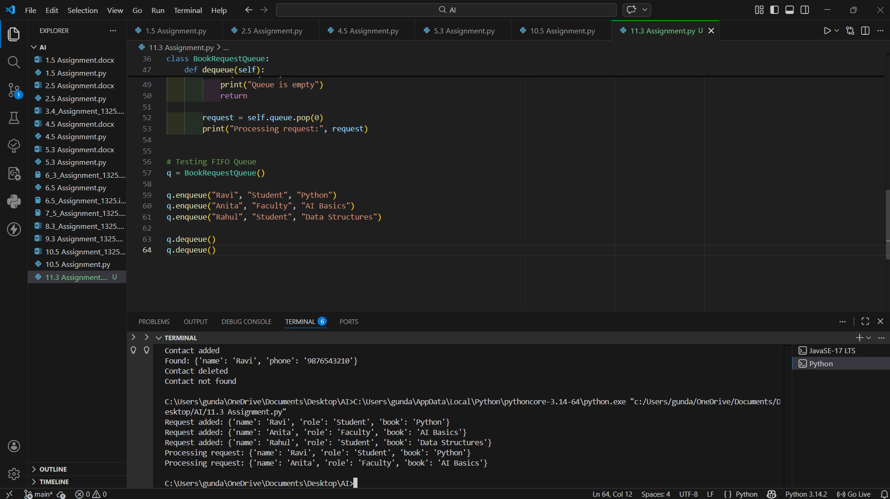
2. Priority Queue Implementation
Code :
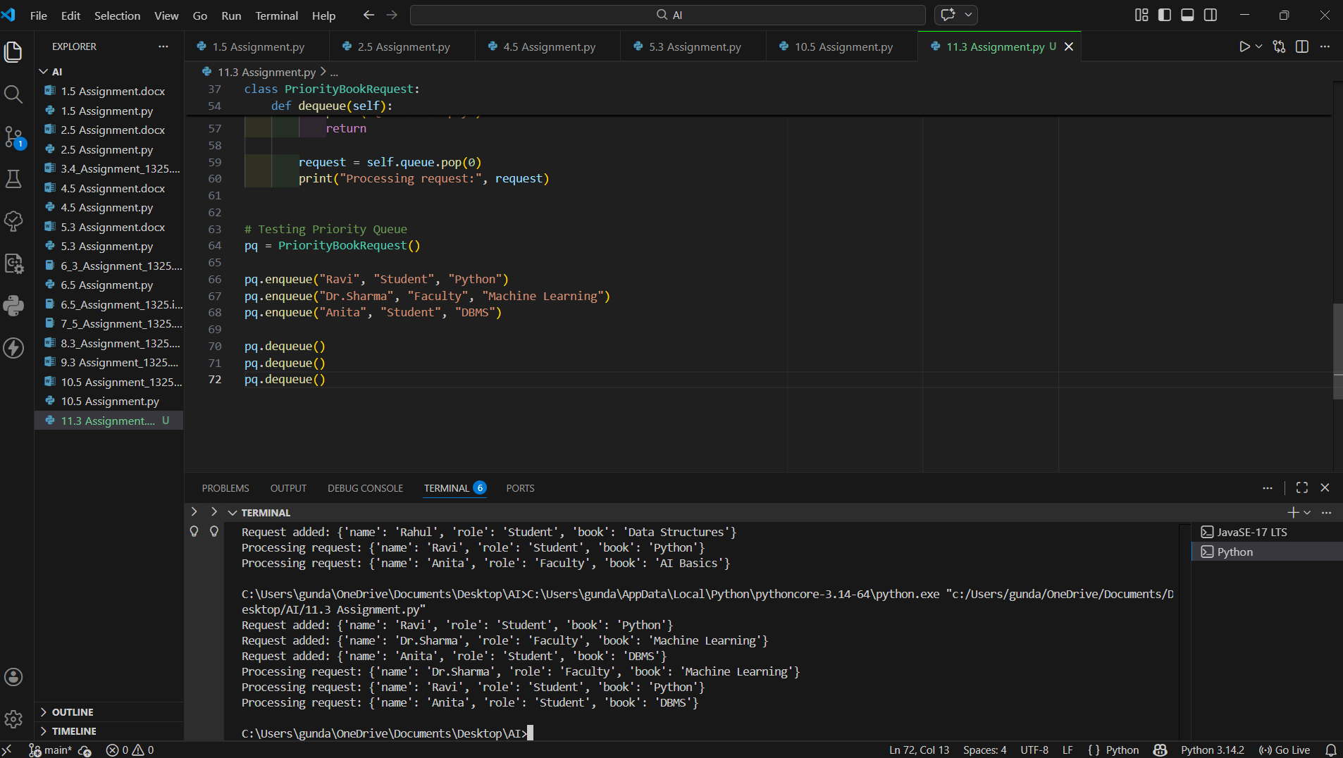
3 .Use GitHub Copilot to assist in generating:
i) enqueue() method
ii) dequeue() method
GitHub Copilot was used to assist in generating the enqueue() and dequeue() methods. Copilot suggested using list operations such as append(), insert(), and pop() to implement queue behavior efficiently. It also helped structure request objects using dictionaries for better data management.
4. Test the system with a mix of student and faculty requests.
Result :
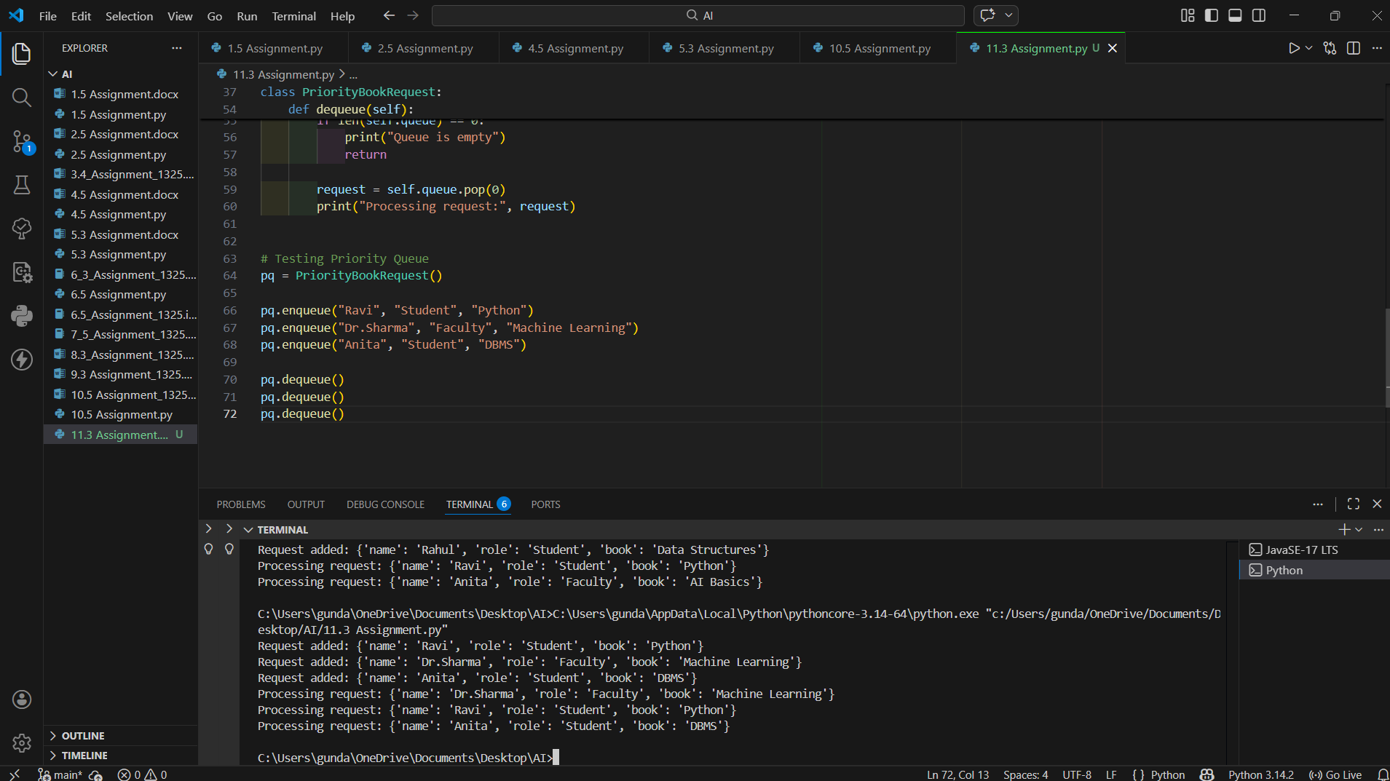
Task 3: Emergency Help Desk (Stack Implementation)
Scenario :
SR University’s IT Help Desk receives technical support tickets from students
and staff. While tickets are received sequentially, issue escalation follows a
Last-In, First-Out (LIFO) approach.
Code :
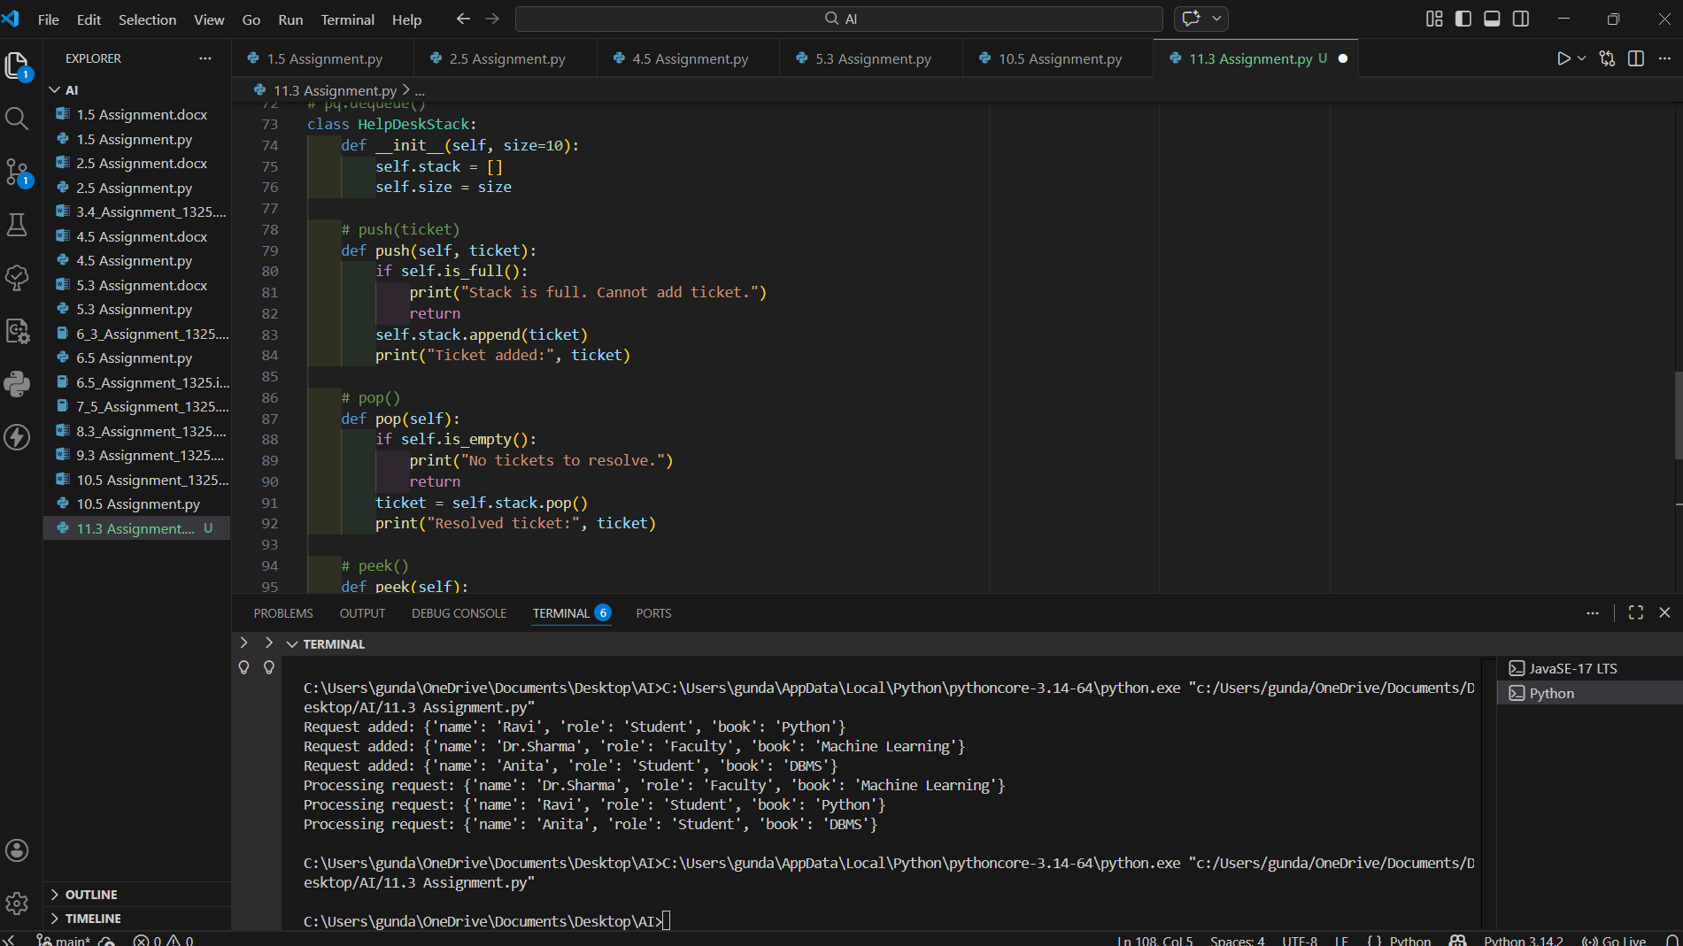
Result :
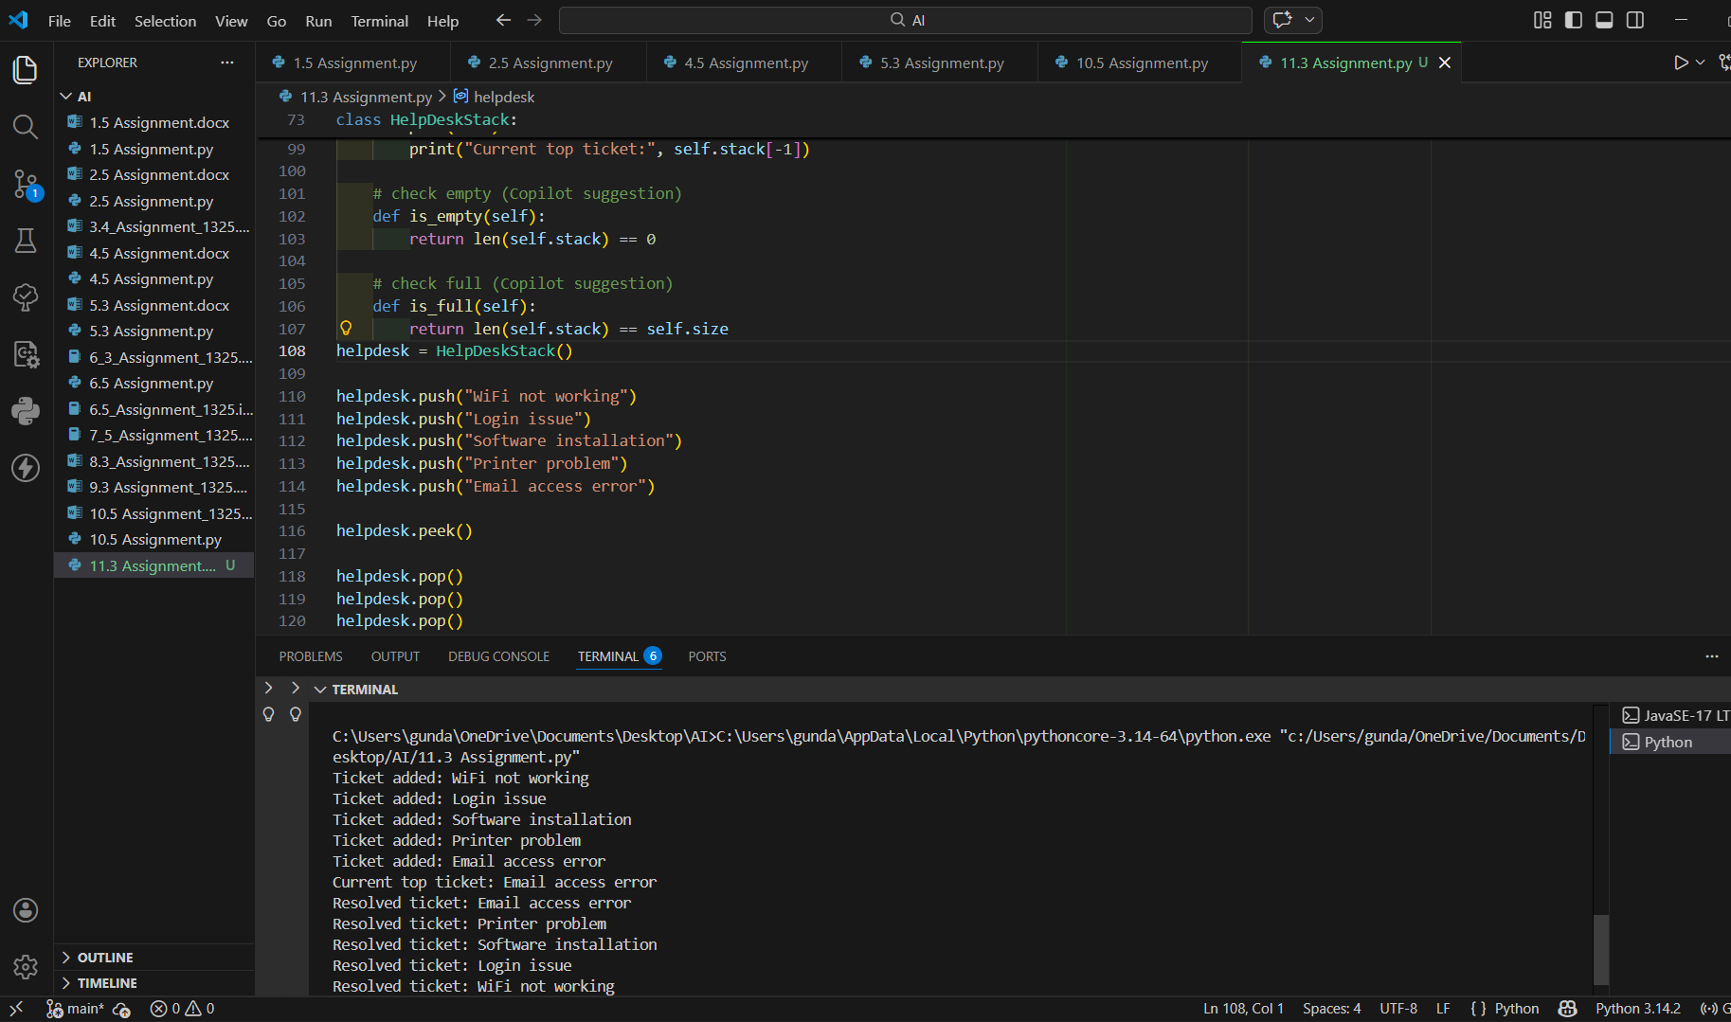
Conclusion :
- A functional stack-based ticket management system was implemented.
- Operations such as push, pop, and peek were successfully performed.
- Additional operations like checking whether the stack is empty or full were implemented using GitHub Copilot assistance.
- The system clearly demonstrates LIFO behavior.
Task 4: Hash Table
Objective :
To implement a Hash Table and understand collision handling.
Code :

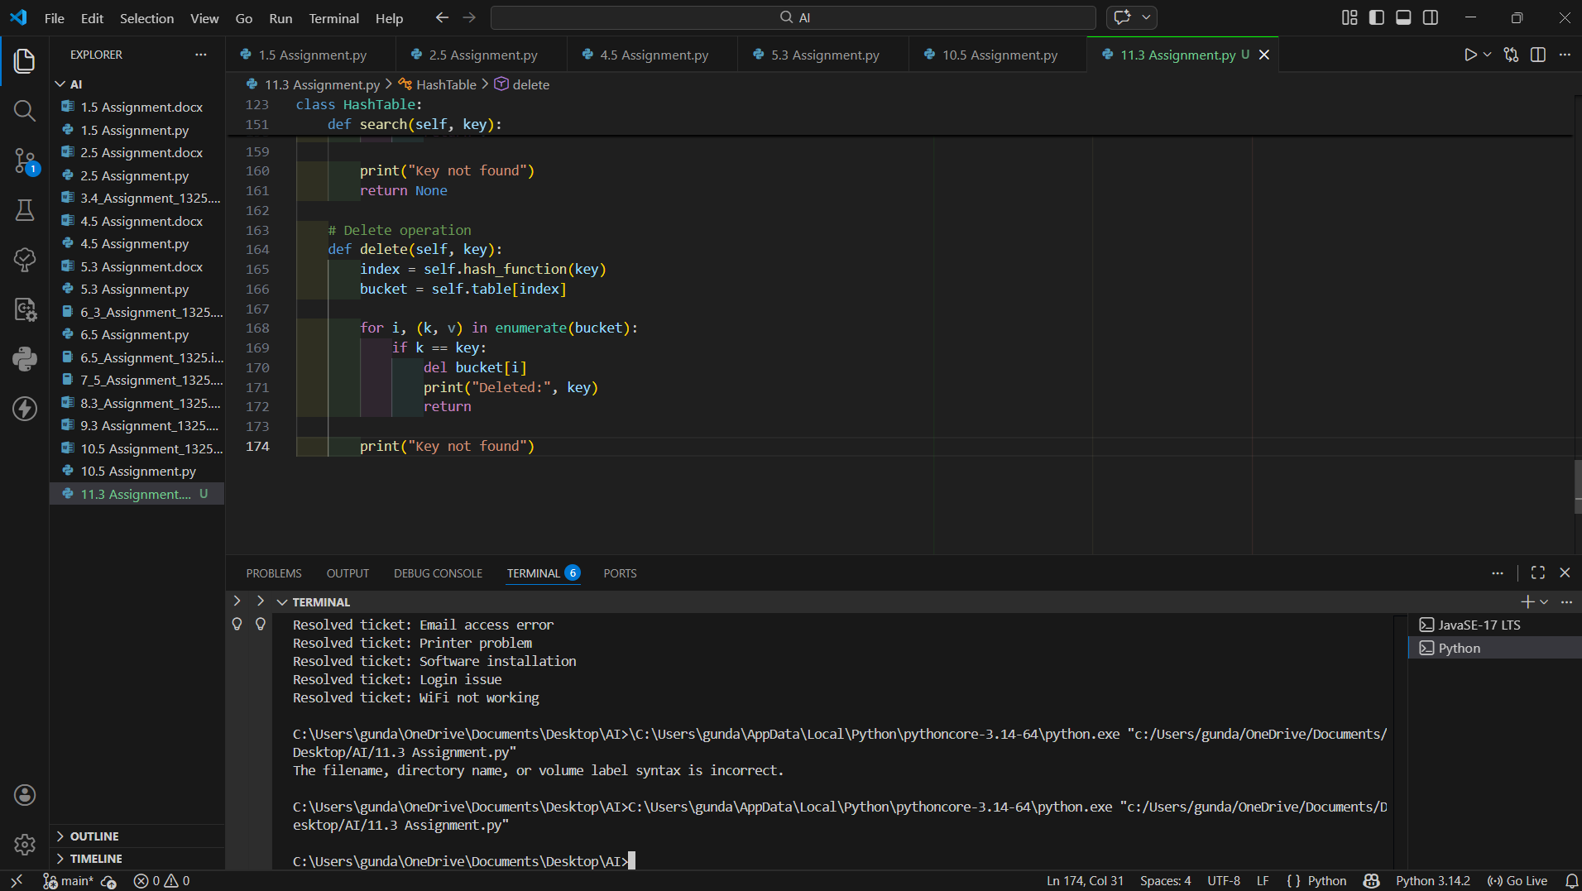
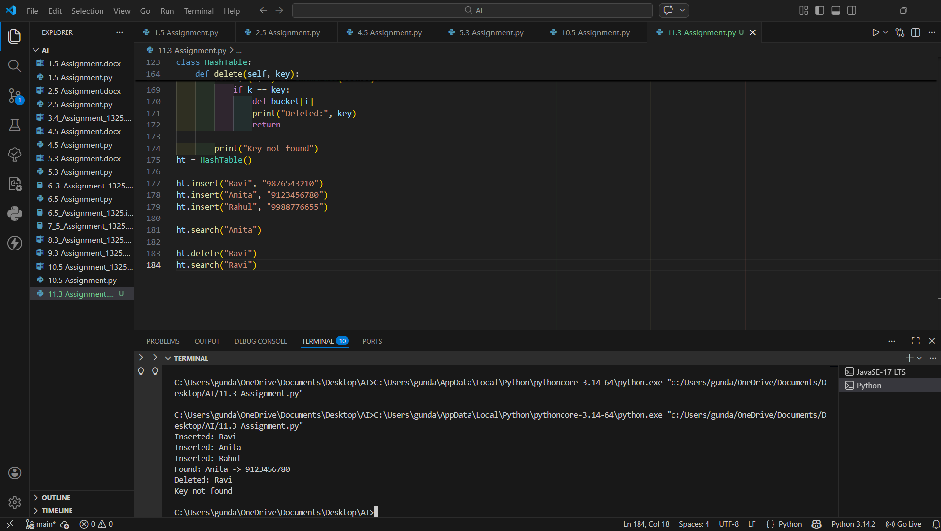
Collision Handling Using Chaining
Collision occurs when two keys produce the same hash index.
In this implementation, collisions are handled using chaining, where each index contains a list (bucket). Multiple key-value pairs are stored inside the same bucket instead of overwriting existing data.
Task 5: Real-Time Application Challenge
This feature manages food orders using a Queue following FIFO behavior.
Code:
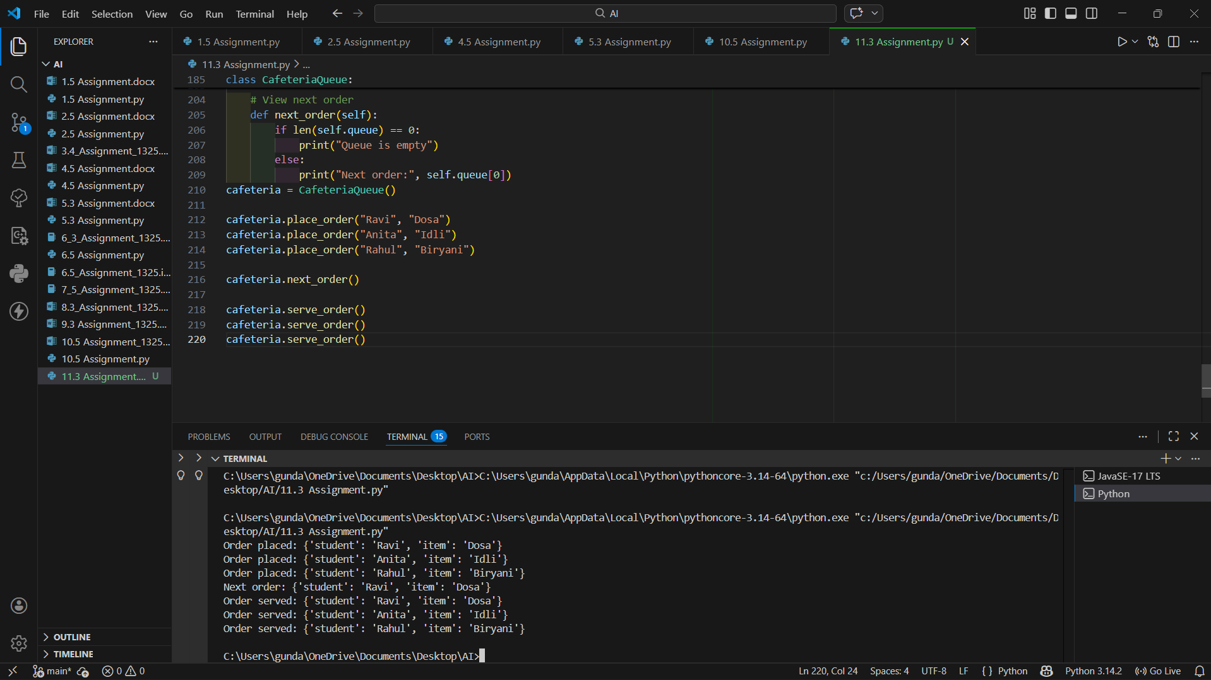
Expected Outcome
- Appropriate data structures were selected for each campus feature.
- Justifications explain why each structure is suitable.
- A working Python implementation of the Cafeteria Order Queue was developed.
- The system correctly demonstrates FIFO behavior.

